

**A Divine Maha Shivaratri Celebrations at Agastya Academy**

At Agastya Academy, Maha Shivaratri, a sacred occasion celebrated by millions of Hindus across the globe, was observed with profound reverence and devotion. It is the festival celebrated for Lord Shiva, when he first performed the Tandava Nritya, the dance of primordial creation, preservation, and destruction. Through this dance of devotion, Lord Shiva saved the world from destruction.

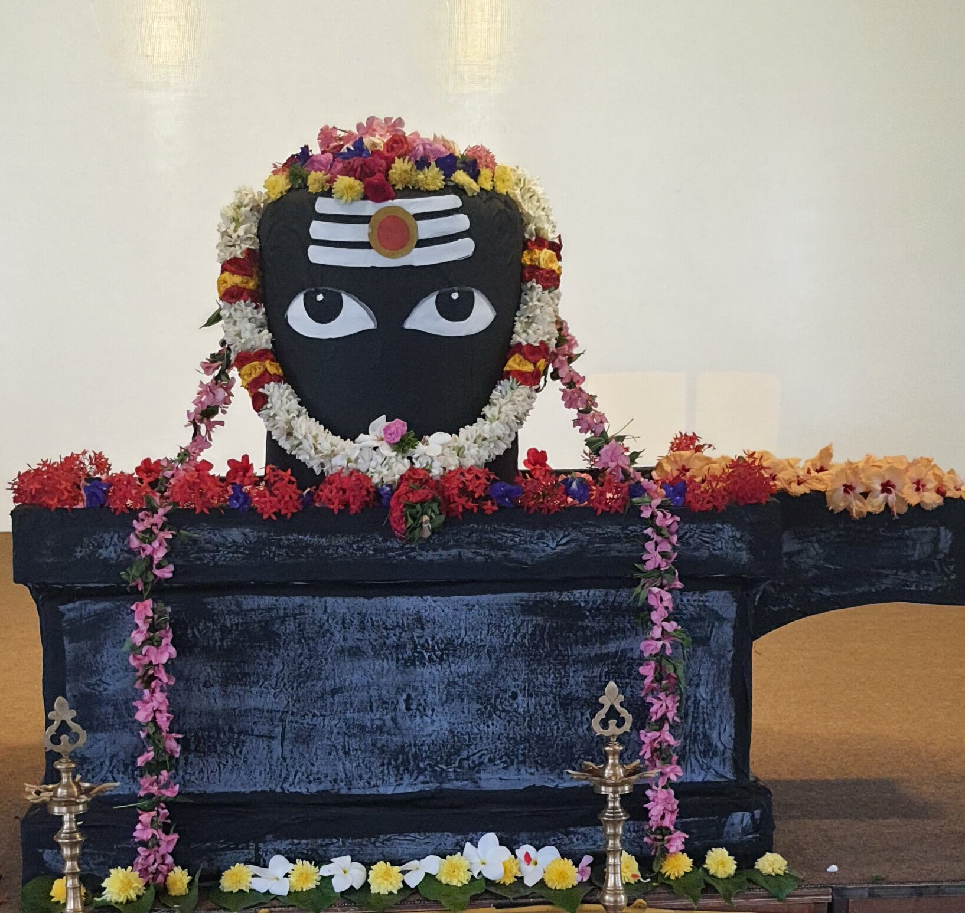

Maha Shivaratri happened on 08.03.2024, the day before the new moon in the month of Masi. So, we organized a special prayer for all the students and faculty to participate and learn about the significance of the event and to offer our prayers to Lord Shiva. Our campus became a blessed space where we, the students and faculty, united in homage to Lord Shiva, the Supreme Being

[Click here for read more.......](https://www.agastyaacademy.edu.in/post/maha-shivaratri-celebrations-agastya-academy)